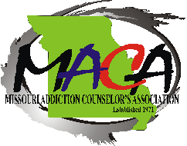
Fall Conference
October 8, 9 and 10, 2021

Camden on the Lake
2359A Bittersweet Rd, Lake Ozarks, MO
CONFERENCE SPEAKER CONFIRMATION
Speaker Information:
Name: Credentials:
Address:
City: State: MO Zip:
Phone #: Work: same Fax:
E-mail:
Biography:

Presentation Information:
Topic: Title:
Synopsis:
Preferences:
1st Choice Friday: 1 PM - 3 PM or Saturday: 2 PM - 5 PM
2nd Choice Friday: 3:30 PM - 5:30 PM or Saturday: 9 AM - 12 PM
3rd Choice Friday: 9:00 am-11 am or Saturday:

Audio/Visual Needs: ☐ Dry Erase board ☐ Flip Chart ☐ PowerPoint Projector ☐ Copies
SPEAKER REIMBURSEMENT: Free Conference or One Nights’ Lodging.

Please review/complete this form and return it to: Tracy Sovar, P O Box 73, Owensville, MO 65066 or email Tracy at tsovarmadac@gmail.com

Any questions, please contact: Kathy Gillum Email: maca@socket.net Phone: 417-372-0123

Please attach picture, and synopsis

